1. **1. Unsharp mask : subtract fraction of neighborhood mean and scale result**



**2. Extremum-sharpening: output closer of neighborhood maximum or minimum**



**3. Facet model**

Image as continuum or piecewise continuous intensity surface

**4. Relative maxima**

相對極大值。在鄰近區間(connected neighbor)中有最大值。

Relative maxima operator的作用是找到每個點在單調遞增中可以reach到的相對極大值。

**5. Peak noise removal**

Remove the outlier or the peak value in the relatively smooth region. 定義threshold和window平均值，如果pixel value-mean>threshold就視為outlier或peak。

**6. Gradient-based edge detection**

Compute gradient magnitude at each pixel. If magnitude a pixel exceeds a threshold, output a possible edge point.

**7. Gray-level primitive**

Texture在gray-level上的組成基本單位。愈大的Gray-level primitive代表texture愈稀疏(coarser)、反之則愈緊密(fine)

**8. Spatial Organization**

Gray-level primitive或說texture的基本單位在texture中的位置分布情形，例如說棋盤格狀或是隨機分布。

**9. Texture segmentation**

根據texture的特性來對影像進行分割，分割後不同的區間理當具有不同的texture性質。

**10. Generative model for texture**

給定一個textured region，透過Generative model可以擷取當中的texture descriptor(參數)或model。

**11. Texture classification**

針對影像中texture的性質來對影像進行分類，將texture相近的影像分在同一類。

**12. Texture transfer**

在處理digital image時，將影像切成許多subimages並用不同basis的向量來表示它，將其轉換到不同的座標空間中。如：對影像用傅立葉轉換。

**13. LBP : Local Binary Pattern**

在local subimage用comparison生成的0/1 binary pattern，可用來做進階的texture應用、人臉辨識。

**14. Rotation-invariant**

一個operation是rotation-invariant代表input signal/image即使旋轉一個角度，計算出來的結果和旋轉前依然相同(或具有和input相同的旋轉對應關係)

**15. Isotropic**

等方向性的。一個pixel的gradient (derivative) magnitude是isotopic，即轉了一個角度後的gradient magnitude還是一樣。如果一個pixel的gradient magnitude是isotropic代表在各方向的gradient強度都相等。

**16. Scale-dependent**

一個影像或pattern是scale-dependent代表用不同的scale(放大/縮小倍率)來觀察會計算出不同的參數、descriptor。

**17. Image segmentation**

partition an image into set of non-overlapping regions(CH10 p.2)

**18. Cluster**

process of partitioning set of pattern vectors into clusters (CH10 p.6)

**19. Histogram mode seeking**

a measurement-space-clustering process

homogeneous objects as clusters in histogram

one pass, the least computation time(CH10 p.11)

**20. Measurement-space-guided spatial clustering**

Use the measurement-space-clustering process to define a partition in measurement space.(CH10 p.10)

**21. Recursive histogram-directed spatial clustering**

**22. Single-linkage region growing**

regard each pixel as node in graph

**23. Hough transform**

method for detecting **straight lines** and **curves** on gray level images.

template matching

requires an **accumulator array**

**24. Arc extraction**

從已經被segment or label好的image 提取出border pixels或者其他pixels，而這些pixels連成一串sequence

**25. Border-tracking**

Input: symbolic image

Output: chainsets of border pixels

順時針把每個LABELED REGION的BORDER PIXELS OUTPUT出來

**26. Corner**

兩條segments (lines)交會點

**27. Junction**

三條或以上的segments (lines)的交會點

1. Show that the Sobel Edge operator contains a built-in smoothing and derivative because it can be obtained by the following convolution:

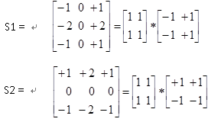

1. What are the four important properties for an edge operator?

accuracy in estimating gradient magnitude

accuracy in estimating gradient direction

accuracy in estimating step edge contrast

accuracy in estimating step edge direction

1. Please fill the blank according to the mathematical properties
2. The total contrast C(T) of edges detected by threshold T is given by



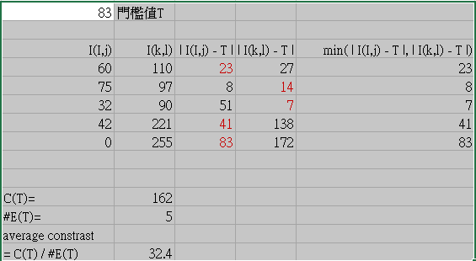

1. Please list at least five techniques which are used to partition arcs into simple segments.

(1) Iterative endpoint fitting and splitting:

split: 找出一sequence中，其垂直距離離兩個endpoints所形成的直線最遠的pixel當作特徵點，若此距離大於threshold，則將特徵點當作新的endpoint把此sequence分成兩條，如此反覆

merge: 把兩段鄰近的sequences連在一起，若連起來後的error值小於之前，則把兩段merge起來

breakpoints optimization: 首先，嘗試移動odd number sequence的尾端點，往後移一個，則這段sequence後面的even number sequence的前端點也往後了一個，這樣新形成的兩段sequence的綜合error若比之前小，則繼續嘗試把endpoint往後挪一個，直到不能再挪。對每一段odd number sequence都做以上嘗試。Odd number sequence都嘗試完再對每一段even number sequence嘗試。

(2) Using tangent angle deflection: 找出sequence中的一個pixel當作切點，而此pixel將sequence分成兩段且由兩段各自的一對endpoints可形成的兩條直線，而這兩條直線所夾的角度會是最大。

(3)curvature: 找出sequence中曲率最大的點當作特徵點將sequence分成兩段。

(4) Uniform Bounded-Error Approximation: 首先，找一個pixel當作一段sequence中的一個endpoint，

1. Bonus
2. 老師的中文姓名：傅楸善
3. 老師的口頭禪：選項C : 好極了 good

3. Joke, 因為笑話比本文重要

4. 犯錯乃人之常情，寬恕乃神之聖行

5. 總共有4句參考答案

a blessing in disguise

Every cloud has a silver lining

When the old man from the frontier lost his horse, how could one have known that it would not be fortuitous?

When the old man lost his horse, who knew it wasn’t a blessing?